How to Fix Softlayer Networking via the Console

Note: If you are unable to RDP to your Windows system on either the public or private IP address, you will need to Console into the system and confirm/fix the networking. This process will take you about 5 minutes and details how to make the changes on Windows 2012.
Screenshots after Step 5 will not match the ‘MyCloud’ screenshot in step 4. Please use your own ‘MyCloud’ details
Step 1: Download TightVNC Java Viewer at: http://www.tightvnc.com/download/2.7.2/tvnjviewer-2.7.2-bin.zip and install on your Windows computer.
Step 2: Open your Cloud Concierge My Cloud webpage
Step 3: Click on the > arrow of the system you need to fix
Step 4: Locate the Console IP address (it also provides you the port # and password)
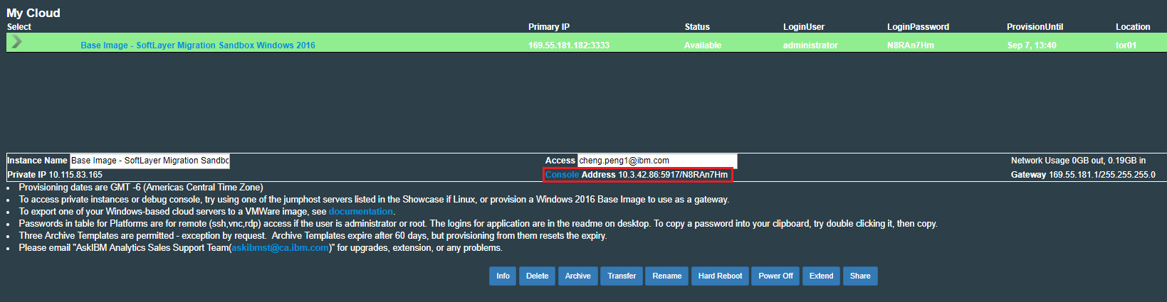
Step 5: Connect to the Softlayer VPN (use link at bottom of My Cloud page if you wish)
Step 6: Launch TightVNC Java Viewer and enter the correct Console IP and Port #
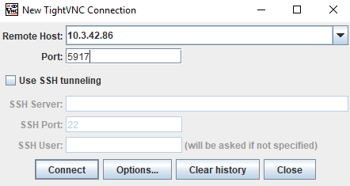

Step 7: You will need to hand type in the password
Step 8: In TightVNC, click the icon that will send Ctrl-Alt-Del and log into Windows
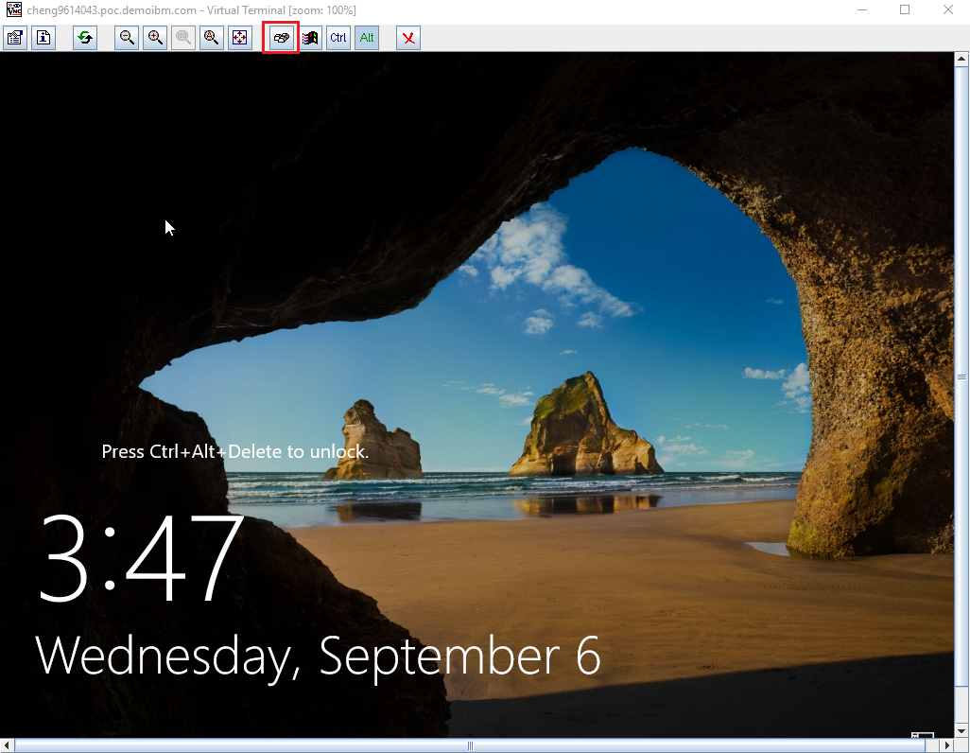
Step 9: On the Taskbar near the clock, right click the networking icon and choose Open Network and Sharing Center

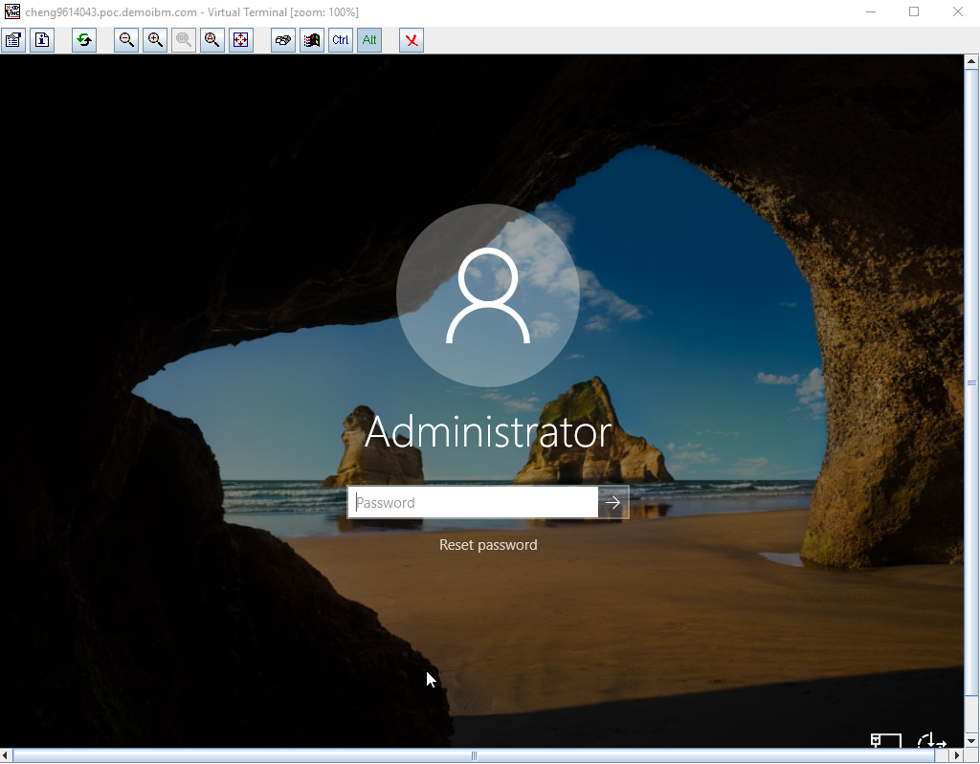

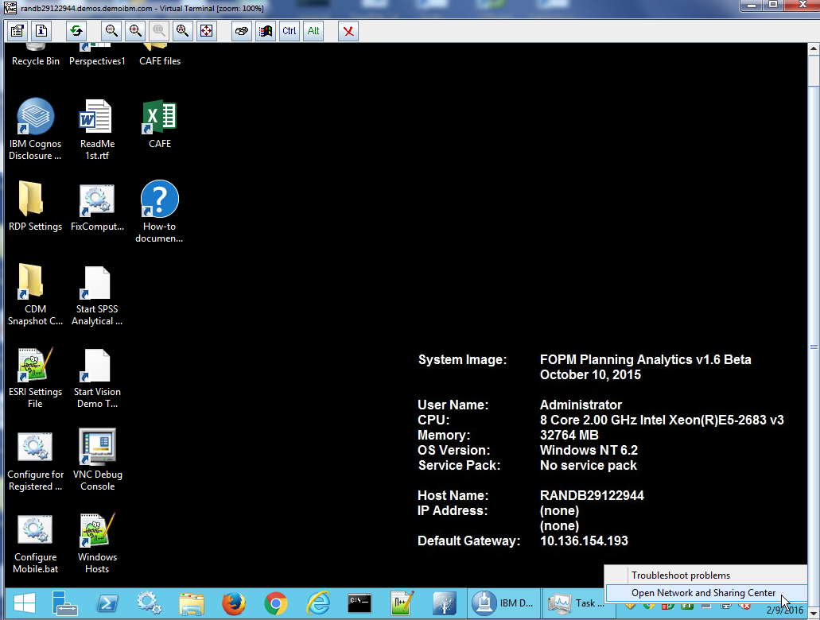

Step 10: Click on the Public Network Connection
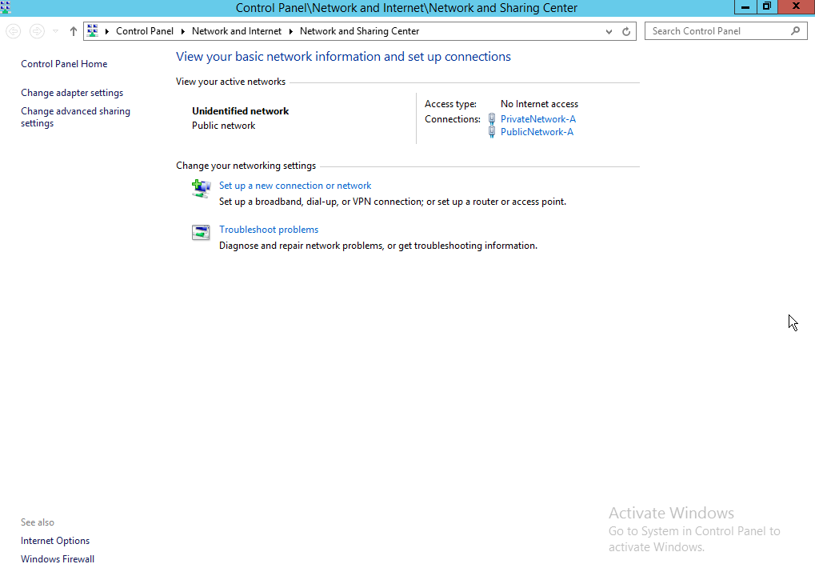
Step 11: Click the Properties button
Step 12: Highlight the Internet Protocol Version 4 (IPv4)
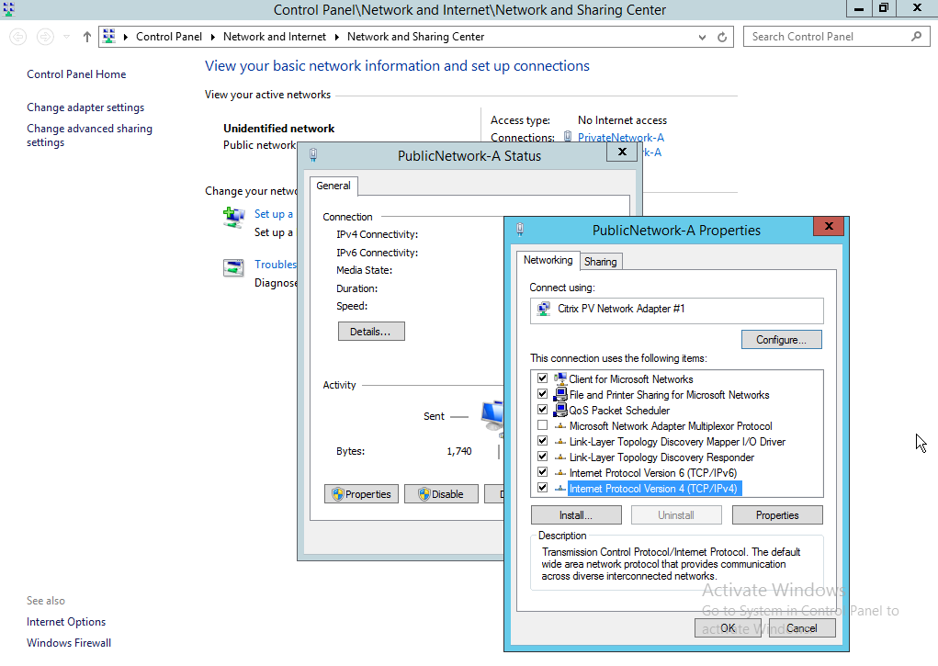

Step 13: Click Properties
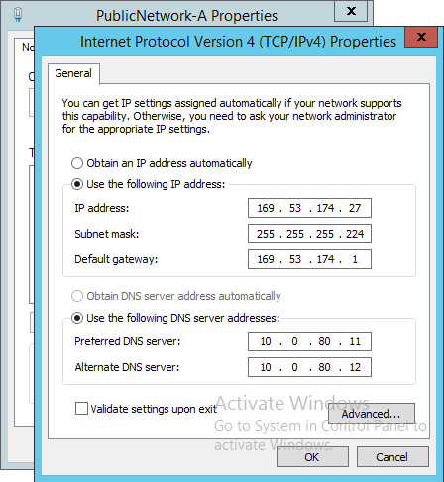

Step 14: Edit the IP Address and Default Gateway as per the details on your My Cloud webpage
Step 15: Click OK until the popup boxes are gone
Step 16: Repeat Steps 9-15 for the Private Network
Step 17: You should now be able to RDP into the public IP. To RDP into the private, remember you need to be on the Softlayer VPN first.

